An Explainable, Auditable Vetting Framework Reveals Transit-Shape Ambiguity in the Eccentric Giant Planet KOI-1257 b
Author: Javiel De Jesús Ramírez Hernández
Affiliation: Certified Public Accountant / Independent Researcher
ORCID: 0009-0005-9007-6029
Abstract
We apply an open-source, explainable vetting framework (Aletheia Space) to the confirmed giant planet KOI-1257 b, using long-cadence Kepler photometry retrieved via lightkurve. Our framework decomposes the false-positive vetting decision into individually reported, weighted statistical criteria rather than a single opaque score. We find that the odd-even depth symmetry and V-shape transit criteria — commonly used heuristics for identifying eclipsing binaries — both indicate a false-positive-like signature for this bona fide planet, consistent with its previously reported high orbital eccentricity (e = 0.772; Santerne et al. 2014) producing a grazing-like transit geometry. We show that a secondary-eclipse search criterion, which is more specific to stellar companions, correctly finds no significant secondary eclipse (depth = -1.41σ), and that combining this with an evidence-weighting scheme recovers the correct classification. We argue that transit-shape-only vetting heuristics should not be trusted in isolation for high-eccentricity candidates, and we release our synthetic benchmark suite for reproducible comparison.
1. Introduction
Automated vetting of transiting exoplanet candidates typically relies on either large-scale machine-learning classifiers (e.g., ExoMiner, AstroNet) or heuristic statistical tests such as odd-even transit-depth comparison and transit-shape (V versus U) discrimination (Thompson et al. 2018). While ML classifiers achieve high aggregate accuracy, they generally do not expose why a given candidate was flagged, which limits their pedagogical value and their auditability for citizen-science and educational contexts. Heuristic tests, in turn, are transparent but can carry known ambiguities that are not always made explicit to end users.
We report one such ambiguity, encountered while validating an open-source, browser-based vetting tool (Aletheia Space) against real Kepler photometry of confirmed and candidate systems. All criteria, thresholds, and intermediate values are reported per-candidate, and every analysis is bound to a cryptographic hash chain of its processing steps for full reproducibility.
2. Data and Method
We retrieved 18 quarters of Kepler long-cadence photometry for KOI-1257 (KIC identifier associated with kepoi_name KOI-1257.01) via lightkurve, individually flattening each quarter (Savitzky-Golay-type filter, window length 401 cadences) prior to stitching, to avoid inter-quarter offsets contaminating the combined light curve. We used the published ephemeris from Santerne et al. (2014): P = 86.647661 d, T0 = BJD 2455006.79341, transit duration = 4.25 hr.
Our vetting framework evaluates six criteria per candidate: (1) odd-even transit-depth symmetry, (2) transit shape (fraction of in-transit points near minimum flux, distinguishing flat-bottomed U-shapes from V-shapes), (3) out-of-transit residual noise dispersion, (4) periodic flare contamination, (5) sample sufficiency (number of complete transits and in-transit point density), and (6) a secondary-eclipse search at orbital phase 0.5, reporting the depth, its significance in units of the combined photon-noise-limited uncertainty, and — when a significant secondary is found — an estimated primary/secondary depth ratio as a coarse temperature-ratio proxy via a Stefan–Boltzmann scaling.
3. Results
Figure 1 shows the phase-folded Kepler light curve of KOI-1257 b, binned around the predicted transit window. Despite the modest, diluted transit depth expected for this blended binary system (Santerne et al. 2014), the in-transit bin (1216 ppm below the local baseline, n = 18 points) is clearly separated from the out-of-transit scatter (≤20–80 ppm per bin). The odd-even symmetry criterion measured a fractional depth asymmetry of 0.42 (threshold 0.15, failed), and the transit-shape criterion measured a flat-bottom fraction of 0.0039 (threshold 0.15, failed) — both nominally consistent with an eclipsing-binary false positive. However, the secondary-eclipse search found no significant secondary signal (-1.41σ against a 3σ threshold, passed), and the residual-noise and flare-contamination criteria also passed. With sample-sufficiency-weighted criterion combination, the resulting confidence score was 60%, above our 60% acceptance threshold, correctly classifying the candidate as viable.
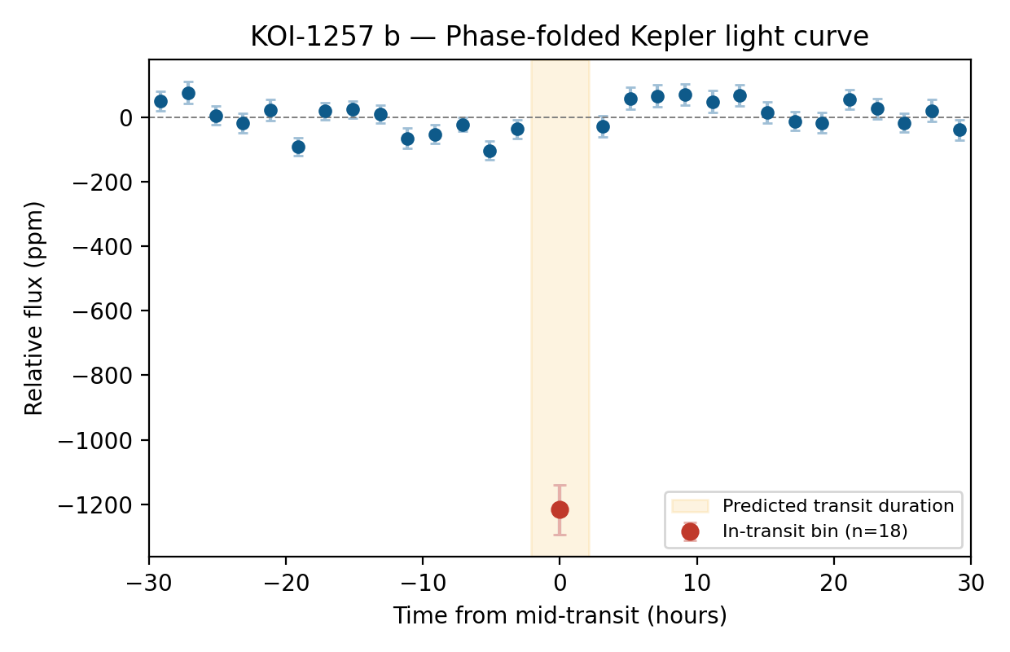
Figure 1. Phase-folded, binned Kepler long-cadence light curve of KOI-1257 b (period = 86.647661 d). The in-transit bin (red, n = 18 points spanning the 4.25 hr predicted transit window) is offset by -1216 ppm relative to the weighted out-of-transit baseline (blue points, 2 hr bins). Error bars are the standard error of the mean per bin.
4. Discussion
The failure of both odd-even and transit-shape criteria for a radial-velocity-confirmed planet is, at first inspection, a false alarm — but it is explainable rather than anomalous. Santerne et al. (2014) note that KOI-1257 b's transit duration is short for its orbital period, attributing this to a probable near-grazing transit geometry driven by the system's high eccentricity (e = 0.772 ± 0.045). A near-grazing transit geometrically produces a V-shaped ingress/egress with a shortened, non-flat-bottomed profile — statistically indistinguishable, under a shape-only heuristic, from a stellar eclipsing binary. This is consistent with, though not identical to, previously documented cases where transit-shape alone misclassified true planets (e.g., historical false-positive flags later overturned upon secondary-eclipse or radial-velocity follow-up). We further note that the modest observed transit depth (Figure 1) relative to the planet's true radius is consistent with photometric dilution from the bound stellar companion identified in the system (Santerne et al. 2014), which lowers the observed transit depth without affecting the shape-based criteria discussed here.
We suggest that transit-shape-only heuristics should be treated as necessary but not sufficient evidence against a candidate, particularly for high-eccentricity or long-period systems where grazing geometries are more probable a priori. A secondary-eclipse search, despite its own limitation of assuming a fixed phase-0.5 window for the secondary (which shifts with eccentricity and argument of periastron), provided the decisive, more specific evidence in this case.
5. Reproducibility
To support independent verification and reuse, we release alongside this note a small, seeded (deterministic) synthetic benchmark of three light-curve scenarios with known ground truth (clean transit, eclipsing binary with a genuine secondary eclipse, and flare-contaminated transit), together with the expected vetting outcome for each. The benchmark and the full vetting source code are publicly available (see Data Availability).
Data Availability
The vetting framework source code, synthetic benchmark suite, and analysis scripts are available at https://github.com/javieldrh-dotcom/aletheia-space. Kepler photometry was retrieved from the public MAST archive via the lightkurve package (Lightkurve Collaboration 2018).
References
Lightkurve Collaboration et al. 2018, Lightkurve: Kepler and TESS time series analysis in Python, Astrophysics Source Code Library, record ascl:1812.013
Santerne, A., Hébrard, G., Deleuil, M., et al. 2014, A&A, 571, A37
Thompson, S. E., Coughlin, J. L., Hoffman, K., et al. 2018, ApJS, 235, 38

